**CS 5200 - Database Management Systems**Project Proposal for

**GYM MANAGEMENT SYSTEM**

Group Name: KulkarniNMagdumT  
Group Members: Nikhil Kulkarni, Tanvi Magdum

**INTRODUCTION:**

Gold’s Gym has a chain of gyms all around United States. A gym needs to keep track of its members, training staff, equipment, rooms, activities and the equipment cleaning staff. This gym will then be able to use the data in this portal to do a quick analysis on the data provided. The gym also needs to keep track of all the equipment and do the maintenance for the same. The database also contains the rooms every branch of the gym has and what activities take place in it.

Depending upon the role, gym staff (gym manager) will be able to login to the web portal by clicking on ‘Log In’ button. The manager will be able to add, update or delete the member, trainer and cleaning staff information. Moreover, the manager can add, edit or remove the activities conducted in the gym or the list of equipment owned by the gym.

The manager can perform search operation on all entities. A filter can also be set while searching. The manager can also sort results in ascending or the descending order of desired column.

Finally, there will a ‘Sign out’ button so that user logs out of the system.

**SOFTWARE:**

We would be using MySQL as our database. We plan to use Python to interact with the data as a user, and the Django framework to achieve this. Django has many inbuilt features, and it is very versatile, compatible with majority of databases. User will interact with the web-interface and MySQL will run the queries and generate data.

**RATIONALE:**

Recently we faced a pandemic which has affected the healthy life of numerous people. In today’s world where the data is produced at such an enormous rate, we can make use of such appropriate data, analyze and take steps to improve people’s health. Hence, there is a need of Gym Management System for every gym through which, the data can be used to analyze what percent of people in a certain area attends gym to maintain their healthy lives and what all exercises they perform to stay fit.

**ACTIVITY DIAGRAM:**

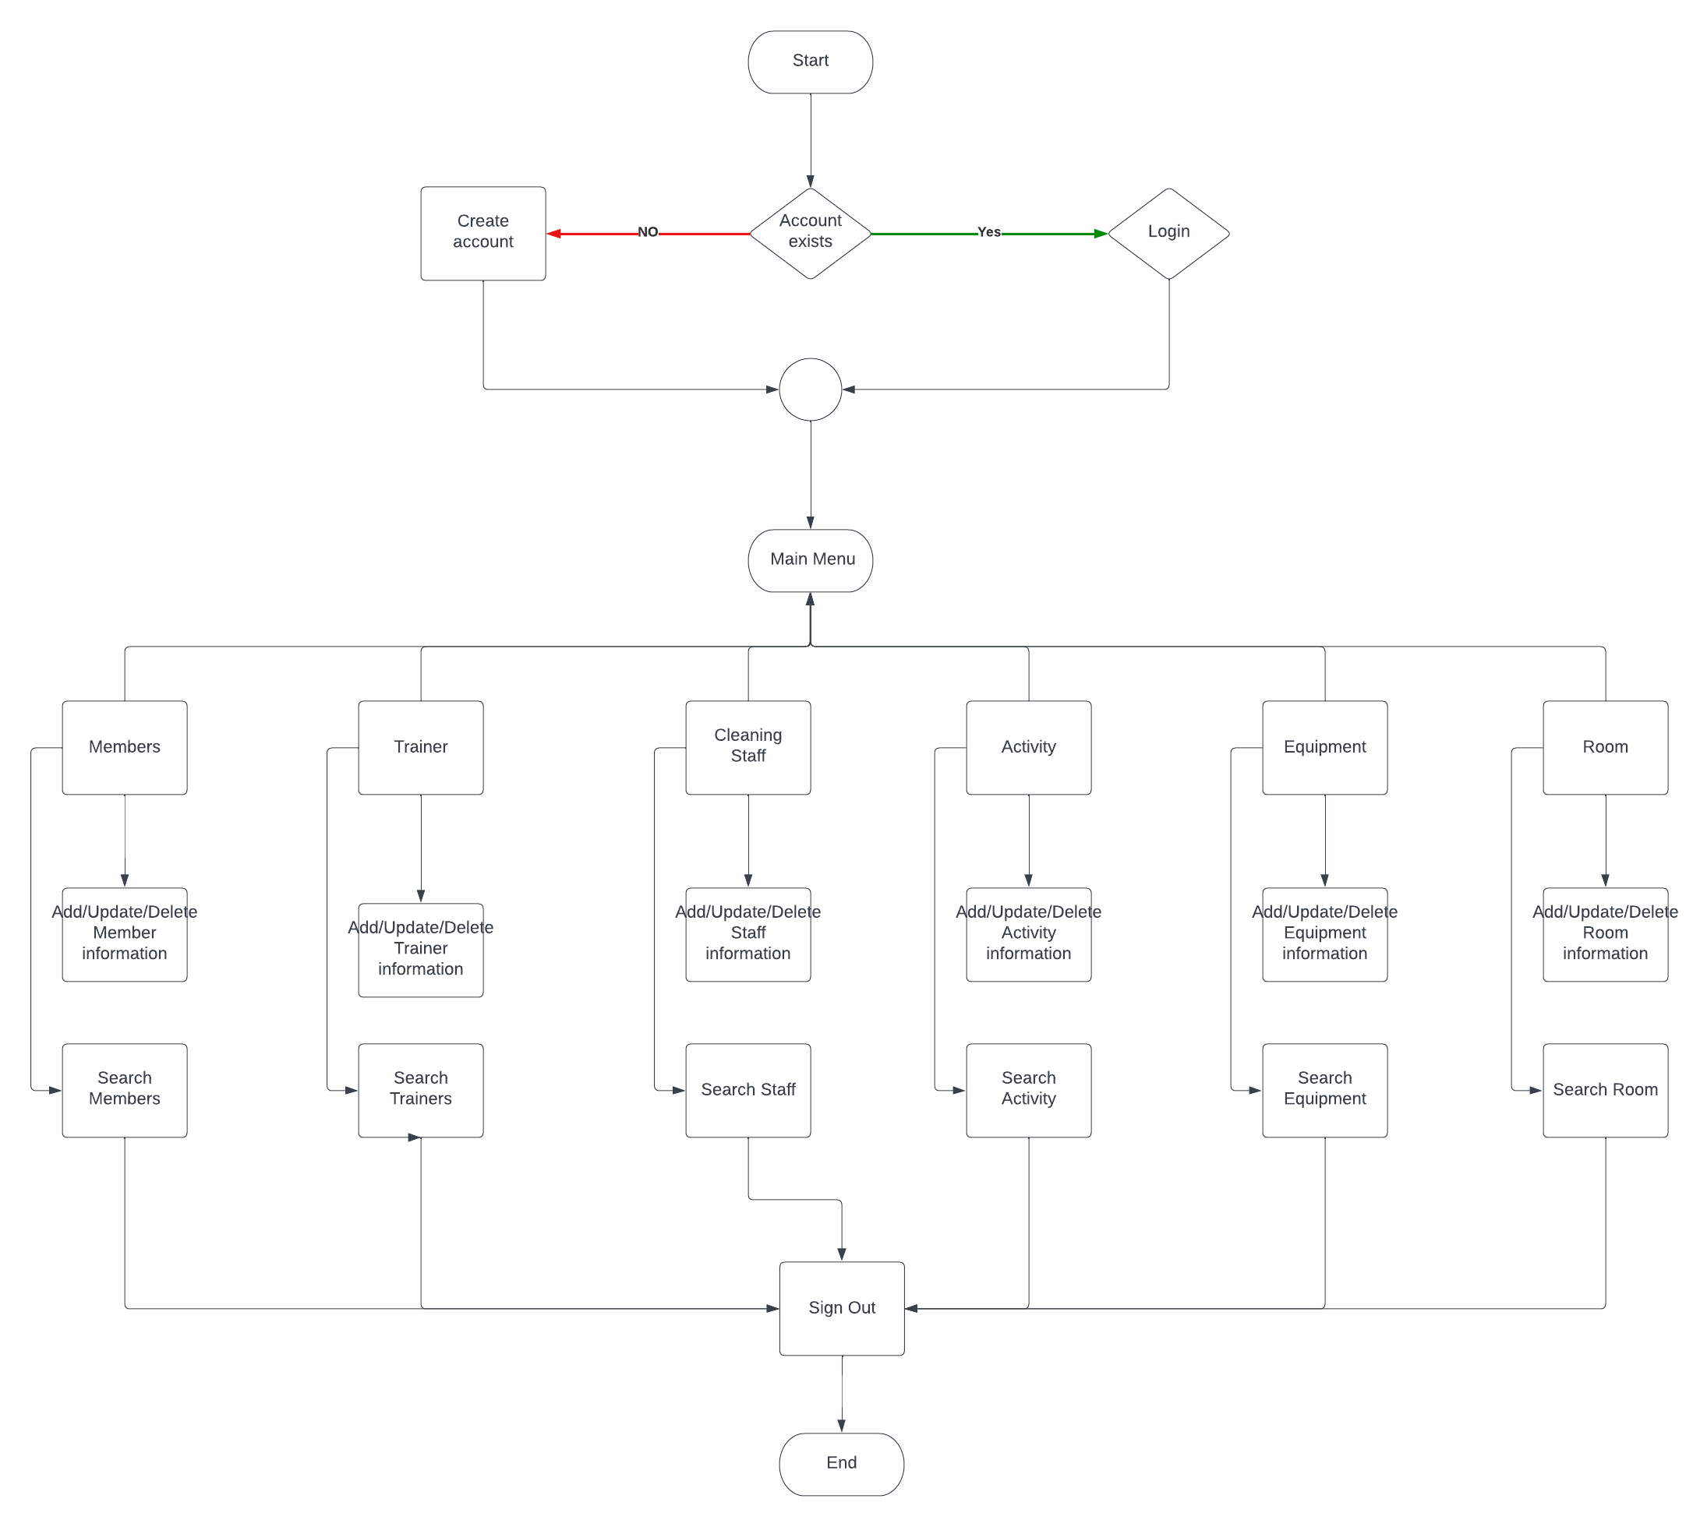

**UML DIAGRAM:**

